**“HEART SURGERY SIMULATION USING HAPTIC GLOVES IN VIRTUAL REALITY”**

Submitted in fulfilment of the requirement of

**University of Mumbai**

For the Degree of

**Bachelor of Computer Engineering**

Submitted By:

**Rahul Anand (47)**

**Anurag Singh (61)**

**Sudhir Yadav (71)**

Under Guidance of

**Prof. Deepti V. Chandran**



Department of Computer Engineering

**Smt. Indira Gandhi College of Engineering**

**Ghansoli Navi Mumbai 400701**

Affiliated to University of Mumbai

(2018-19)

**Project Report Approval Certificate**

This project report entitled as by **Heart Surgery Simulation Using Haptic Gloves in Virtual Reality**

By

**Rahul Anand (47)**

**Anurag Singh (61)**

**Sudhir Yadav (71)**

Is approved for the degree of **Bachelor of Engineering** in **Computer**

**Engineering,**University of Mumbai.

Date:

Place: **GHANSOLI, NAVI MUMBAI**

--------------------------- ------------------------------

***External Examiner*** ***Prof. Deepti V. Chandran***

Internal Guide

------------------------ -------------------------

***Dr. K.T. Patil Dr. Sunil Chavan***

Head of Department Principal

**DECLARATION**

We declare that this written submission represents our own ideas in our own words and where other ideas or words have been included, we have adequately cited and referenced the original sources. We also declare that we have adhered to all principles of academic honesty and integrity also have not misrepresented or fabricated or falsified any idea/ fact/ data/ source in our submission. We understand that that any violation of the above will be cause for disciplinary action by the institute and can also evoke penal action from the sources which have thus not been properly cited or from proper permission has not been taken when needed.

Date:

Place: **GHANSOLI, NAVI MUMBAI**

------------------

(Signature)

-------------------------------------------------

(Name of Student and Roll No.)

-----------------

(Signature)

-------------------------------------------------

(Name of Student and Roll No.)

-----------------

(Signature)

-------------------------------------------------

(Name of Student and Roll No.)

**ABSTRACT**

Humans are capable of haptically perceiving the shape of an object by simply wielding it, even without seeing it. On the other hand, typical hand-held controllers for virtual reality (VR) applications are pre-designed for general applications, and thus not capable of providing appropriate haptic shape perception when wielding specific virtual objects. Contradiction between haptic and visual shape perception causes a lack of immersion and leads to inappropriate object handling in VR. To solve this problem, we propose a novel method for designing hand-held VR controllers which illusorily represent haptic equivalent of visual shape in VR. In ecological psychology, it has been suggested that the perceived shape can be modelled using the limited mass properties of wielded objects. Based on this suggestion, we built a shape perception model.

Using a data-driven approach; we aggregated data of perceived shapes against various hand-held VR controllers with different mass properties, and derived the model using regression techniques. We implemented a design system which enables automatic design of hand-held VR controllers whose actual shapes are smaller than target shapes while maintaining their haptic shape perception. We veried that controllers designed with our system can present aimed shape perception irrespective of their actual shapes.

# List of Abbreviations

* B.E. :Bachelor of Engineering
* V.R. :Virtual Reality
* DFD: Data Flow Diagram
* C4D: Cinema 4D
* UE4: Unreal Engine 4
* MPU: Multi-Purpose Unit

# LIST OF FIGURES

* Figure 3.1: Spiral Model………………………………………….….…....13
* Figure 4.2.1: Level 2 DFD…………………………………………….…..23
* Figure 5.1: Flowchart Diagram……………………………………………27
* Figure 5.1.1: Use Case Diagram…………………………………………..28
* Figure 5.1.2: Activity Diagram……………………………………………29
* Figure 5.1.3: Sequence Diagram…………………………………………..30
* Figure 5.1.5. Class Diagram………...……………………………………..31
* Figure 5.1.6. Plugin Flow Diagram………………………………………..32

# LIST OF TABLES

TABLE 3.2 Timeline Chart……………………………………………………….14

**INDEX**

|  |  |  |
| --- | --- | --- |
| **ChpNo.** | **Contents** | **Page No.** |
|  | **Abstract** | **i** |
|  | **List of Abbreviations** | **ii** |
|  | **List of Figures** | **iii** |
|  | **List of Tables** | **iv** |
| **1** | **INTRODUCTION** | 1 |
|  | 1.1 Problem Statement | 2 |
|  | 1.2 Objective | 3 |
|  | 1.3 Scope | 3 |
|  | 1.4 Report Organisation | 4 |
| **2** | **REVIEW OF LITERATURE** | 5 |
|  | 2.1 Research Papers Analysis | 6 |
|  | 2.2 Comparative Analysis | 7 |
| **3** | **PLANNING AND FORMULATION** | 12 |
|  | 3.1 Project Methodology | 13 |
|  | 3.2 Timeline Chart | 14 |
|  | 3.3 Feasibility Study | 15 |
|  | 3.4 Functional and Non-Functional Requirements | 16 |
|  | 3.4.1 Functional Requirements | 17 |
|  | 3.4.2 Non-Functional Requirements | 17 |
| **4** | **REQUIREMENT ANALYSIS** | 18 |
|  | 4.1 Risk Analysis | 19 |
|  | 4.2 System Requirements | 20 |
|  | 4.2.1 Hardware Requirements | 20 |
|  | 4.2.2 Software Requirements | 21 |
|  | 4.3 Data Flow Diagrams | 23 |
| **5** | **PROPOSED SYSTEM** | 24 |
|  | 5.1 System Design | 25 |
|  | 5.1.1 Flow Chart | 27 |
|  | 5.1.2 Use Case Diagram | 28 |
|  | 5.1.3 Activity Diagram | 29 |
|  | 5.1.4 Sequence Diagram | 30 |
|  | 5.1.5 Class Diagram | 31 |
|  | 5.1.6 Plugin Diagram | 32 |
|  | 5.2 Algorithm Development | 33 |
| **6** | **IMPLEMENTATION** | 35 |
|  | 6.1 Screenshot | 36 |
| **7** | **RESULT AND DISCUSSION** | 38 |
| **8** | **CONCLUSION** | 40 |
|  | 8.1 Conclusion | 41 |
|  | 8.2 Future Scope | 44 |
|  | **REFERENCES** | 42 |
|  | **ACKNOWLEDGEMENTS** | 43 |
|  | **IEEE PAPER PUBLISHED** | 44 |
|  | **ICATE 2019 CERTIFICATE** | 50 |

CHAPTER 1

**INTRODUCTION**

1. **INTRODUCTION**

Presently, many types of training are made already in virtual reality (VR) environ. In these ambient users can undergo tasks involving human risks or else critical, like military combat strategies or else surgeries. Some authors recommend the training simulators usage in the medicinal field for enhancing physician training with assessment, that could provide more security for patients and also in the health care method .In such case, the scientific literature evidenced that training based on VR enhances individual medical talents. Thus, environments of realistic virtual reality have been built by training objectives for immersing the user within a virtual world in which simulations of actual situations can be done. For several health care professionals, VR has first place among all technology. The VR is demonstrated as an accumulation of the technological devices: a computer having the ability of interactive 3D visualization, a head-mounted display plus data gloves supplied with one or more position trackers. Here, the trackers assume the position, the sense and orientation of the user and inform that information of the computer renovates the images to display. Anyhow, the variant VR applications analysis vividly presents that the aim on technological devices is variant based on health care provider development. Though there is a few proof presenting such simulators, it can proffer the required training quality and verifying, their profile of cost makes them inappropriate for usage by student populations who are outside of their facility of training. We should reassess the VR role in surgical training plus planning due to rapid enhancement of virtual reality and due to rapid moving of the new technology into the operating room. the virtual reality system utilizing computer picture of the past, the maturity of hardware level, the appropriate originals have been fixed, the developers desire make original of your own is very tough, if foreign purchases of words, dozens s image, it will have cost a few million, and hence, it is for preparing the corresponding spot of a different typed of hardware, Hence it is very tough and very costly. Moreover, big -performance equipment delivery also needs distinctive technical knowledge. Hence, Systems of virtual reality systems for the Neuro computer graphics packages are having no cost, fixed equipment is tiny, and unique requirements of the patient are minimized greatly, there is no need addressing many computer graphics expertise virtual reality system requirements is not required as it augments constantly.

**1.1 PROBLEM STATEMENT:**

Virtual reality technology can serve as a useful adjunct to traditional heart surgical planning techniques. Basic research in image processing and segmentation of computed tomography and magnetic resonance scans has enabled reliable 3D reconstructions of important anatomical structures.

**1.2 OBJECTIVE**

* The main objective of this project is that the medical students don’t get the opportunity to perform or to do heart surgery in living human body so they don’t get adequate training to do so.

**1.3 SCOPE OF PROJECT**

* So we have chosen this project because we can make the medical students perform heart surgeries in virtual world where we can make them feel as if they are performing it in real. The main scope of the project is mainly based for educational purpose where students get to train and perform and get experience by doing so.

**1.4 REPORT ORGANIZATION**

* **Chapter 2- Review of Literature**: The literature review is a written overview of major writings and other sources covered in the review include scholarly journal articles, books, reports etc. The literature review provides a description, summary and evaluation of each source.
* **Chapter 3- Planning and formulation**: This chapter guides project execution and control. It explains in detail how and when to fulfil the project objectives by showing the major products, milestones, activities, and resources required on the project.
* **Chapter 4- Requirement Analysis**: The requirements analysis and specification phase starts once the feasibility study phase is complete and the project is found to be technically sound and feasible. The goal of the requirements analysis and specification phase is to clearly understand customer requirements and to systematically organize these requirements in a specification document.
* **Chapter 5-** **Proposed System**: This chapter describes about all the algorithm and method used in the software. Also the proposed system architecture and UML diagram are also included.
* **Chapter 6**- **Implementation**: Implementation phase involves putting the project plan into action. In this we have describe about the prototype and working of the system. It has all the screenshots of the system.
* **Chapter 7- Result And Discussion**: This chapter has the result about the approaches and methods taken to complete the project with discussion how it works.
* **Chapter 8 – Conclusion**: This chapter thee conclusion and future scope about the project.

CHAPTER 2

**REVIEW OF LITERATURE**

## **2. REVIEW OF LITERATURE**

### **RESEARCH LITERATURE ANALYSIS-**

1) Keynote Address: Haptic Feedback for Virtual Reality Grigore C. Burdea Rutgers- The State University of New Jersey, CAIP Center, 96 Frelinghuysen Rd., Piscataway, NJ 08854, USA.

Published in: Proceedings of International Workshop on Virtual prototyping, Laval, France, pp. 87-96, Date: May 1999

Abstract- Haptic feedback is a crucial sensorial modality in virtual reality interactions. Haptics means both force feedback (simulating object hardness, weight, and inertia) and tactile feedback (simulating surface contact geometry, smoothness, slippage, and temperature). Providing such sensorial data requires desk-top or portable special-purpose hardware called haptic interfaces. Modeling physical interactions involves precise collision detection, real-time force computation, and high control-loop bandwidth. This results in a large computation load which requires multi-processor parallel processing on networked computers. Applications for haptics-intensive VR simulations include CAD model design and assembly. Improved technology (wearable computers, novel actuators, haptic toolkits) will increase the use of force/tactile feedback in future VR simulations.

2) Haptic simulation of tissue tearing during surgery

Quesada, Carlos, Alfaro, I, González, D, Chinesta, Francisco Cueto, Elias

Published in: International Journal for Numerical Methods in Biomedical Engineering Date: September 2017

Abstract- We present a method for the real-time, interactive simulation of tissue tearing during laparoscopic surgery. The method is designed to work at haptic feedback rates (i.e., around 1kHz). Tissue tearing is simulated under the general framework of continuum damage mechanics. The problem is stated as a general, multidimensional parametric problem, which is solved by means of Proper Generalized Decomposition (PGD) methods. One of the main novelties is the reduction of history-dependent problems, such as damage mechanics, by resorting to an approach in which a reduced-order field of initial damage values is considered as a parameter of the formulation. We focus on the laparoscopic cholecystectomy procedure as a general example of the performance of the method.

3) Detección de gestos basado en guante inteligente

Autor: Pablo Ráez Sánchez Directores: Javier Díaz Alonso

Published in: TRABAJO FIN DE MASTER INGENIERIA DE TELECOMUNICACION, Granada, Date: Febrero de 2018

Abstract - In this project you can find the details of the development of a smart glove prototype, called Evolved Glove, as well as a couple of applications which purpose is showing the utility of the glove: a three-dimensional model of a hand that follows the movements the glove does on real time and a gesture detector that is able to control a computer.

Concerning to the glove, its design is based on a Raspberry Pi Zero, which controls the acquisition of data generated on several sensors. Specifically, the glove has a orientation sensor called Adafruit BNO055, as well as several flex sensors which detect the flexion of the fingers. In order to capture the data from these sensors, we make use of ADCs.

The final goal of the project is validating the capabilities of the glove, in order to find useful applications, allowing the final purpose of creating a new company that would sell an improved version of the product.

4) Review on Hand Gesture Recognition using Sensor Glove

Shubham Jadhav, Pratik Shah, Avinash Bagul, Parag Hoshing, Ashutosh Wadhvekar

Student, Computer Department, NBNSSOE, Pune, India, Assistant Professor, Computer

Department, NBNSSOE, Pune, India

Published in: International Journal of Advanced Research in Computer and Communication

Engineering ISO 3297:2007 Certified Vol. 5, Issue 11, Date: November 2016

Abstract - Hand Gesture Recognition is popular concept that has grown its wide roots in the field of technology. Hand Gesture Recognition is being used in various applications, in these one of the major is interpreting of sign language as voice or text using Sensor Glove. This makes use of various sensors such flex sensors, contact sensors and 3 axis accelerometer for making glove, that sends readings recorded by the sensors to the microcontroller that computes these values and generates speech(using voice module) or text(using LCD). Various methods have been implemented to recognise various sign languages for helping the speech impaired. Realization of this application allows speech impaired people to interact with other normal people using the same generic sign language they use to interact, with ease and confidence.

5) Virtual Reality and 3D Visualizations in Heart Surgery Education

Reinhard Friedl, MD1,Melitta B. Preisack, MD, Wolfgang Klas, PhD, Thomas Rose,

Sylvia Stracke, MD, Klaus J. Quast, PhD, Andreas Hannekum, MD, PhD, Oliver Gödje,

MD, PhD, Dept. Cardiac Surgery, University of Ulm, Germany

Published in: Heart Surgery Forum Date: February 2002

Abstract- Computer assisted teaching plays an increasing role in surgical education. The presented paper describes the development of virtual reality (VR) and 3D visualizations for educational purposes concerning aortocoronary bypass grafting and their prototypical implementation into a database-driven and internet-based educational system in heart surgery. A multimedia storyboard has been written and digital video has been encoded. Understanding of these videos was not always satisfying; therefore, additional 3D and VR visualizations have been modelled as VRML, QuickTime, QuickTime Virtual Reality and MPEG-1 applications. An authoring process in terms of integration and orchestration of different multimedia components to educational units has been started. A virtual model of the heart has been designed. It is highly interactive and the user is able to rotate it, move it, zoom in for details or even fly through. It can be explored during the cardiac cycle and a transparency mode demonstrates coronary arteries, movement of the heart valves, and simultaneous blood-flow. Myocardial ischemia and the effect of an IMA-Graft on myocardial perfusion is simulated. Coronary artery stenoses and bypass-grafts can be interactively added. 3D models of anastomotique techniques and closed thrombendarterectomy have been developed. Different visualizations have been prototypically implemented into a teaching application about operative techniques. Interactive virtual reality and 3D teaching applications can be used and distributed via the World Wide Web and have the power to describe surgical anatomy and principles of surgical techniques, where temporal and spatial events play an important role, in a way superior to traditional teaching methods.

**2.2 COMPARATIVE ANALYSIS**

1) Virtual Reality and 3D Visualizations in Heart Surgery Education

Reinhard Friedl, MD1,Melitta B. Preisack, MD1, Wolfgang Klas, PhD2, Thomas Rose,

Sylvia Stracke, MD4, Klaus J. Quast, PhD5, Andreas Hannekum, MD, PhD1, Oliver Gödje,

MD, PhD1,1 Dept. Cardiac Surgery, University of Ulm, Germany

Published in: Heart Surgery Forum Date: February 2002

Abstract- Computer assisted teaching plays an increasing role in surgical education. The presented paper describes the development of virtual reality (VR) and 3D visualizations for educational purposes concerning aortocoronary bypass grafting and their prototypical implementation into a database-driven and internet-based educational system in heart surgery. A multimedia storyboard has been written and digital video has been encoded. Understanding of these videos was not always satisfying; therefore, additional 3D and VR visualizations have been modelled as VRML, QuickTime, QuickTime Virtual Reality and MPEG-1 applications. An authoring process in terms of integration and orchestration of different multimedia components to educational units has been started. A virtual model of the heart has been designed. It is highly interactive and the user is able to rotate it, move it, zoom in for details or even fly through. It can be explored during the cardiac cycle and a transparency mode demonstrates coronary arteries, movement of the heart valves, and simultaneous blood-flow. Myocardial ischemia and the effect of an IMA-Graft on myocardial perfusion is simulated. Coronary artery stenoses and bypass-grafts can be interactively added. 3D models of anastomotique techniques and closed thrombendarterectomy have been developed. Different visualizations have been prototypically implemented into a teaching application about operative techniques. Interactive virtual reality and 3D teaching applications can be used and distributed via the World Wide Web and have the power to describe surgical anatomy and principles of surgical techniques, where temporal and spatial events play an important role, in a way superior to traditional teaching methods.

# 2) Review on Hand Gesture Recognition using Sensor Glove

Shubham Jadhav, Pratik Shah, Avinash Bagul, Parag Hoshing, Ashutosh Wadhvekar

Student, Computer Department, NBNSSOE, Pune, India, Assistant Professor, Computer

Department, NBNSSOE, Pune, India

Published in: International Journal of Advanced Research in Computer and Communication

Engineering ISO 3297:2007 Certified Vol. 5, Issue 11, and Date: November 2016

Abstract - Hand Gesture Recognition is popular concept that has grown its wide roots in the field of technology. Hand Gesture Recognition is being used in various applications, in these one of the major is interpreting of sign language as voice or text using Sensor Glove. This makes use of various sensors such flex sensors, contact sensors and 3 axis accelerometer for making glove, that sends readings recorded by the sensors to the microcontroller that computes these values and generates speech(using voice module) or text(using LCD). Various methods have been implemented to recognise various sign languages for helping the speech impaired. Realization of this application allows speech impaired people to interact with other normal people using the same generic sign language they use to interact, with ease and confidence.

3) Detección de gestos basado en guante inteligente

Autor: Pablo Ráez Sánchez Directores: Javier Díaz Alonso

Published in: TRABAJO FIN DE MASTER INGENIERIA DE TELECOMUNICACION, Granada, Date: Febrero de 2018

Abstract - In this project you can find the details of the development of a smart glove prototype, called Evolved Glove, as well as a couple of applications which purpose is showing the utility of the glove: a three-dimensional model of a hand that follows the movements the glove does on real time and a gesture detector that is able to control a computer.

Concerning to the glove, its design is based on a Raspberry Pi Zero, which controls the acquisition of data generated on several sensors. Specifically, the glove has a orientation sensor called Adafruit BNO055, as well as several flex sensors which detect the flexion of the fingers. In order to capture the data from these sensors, we make use of ADCs.

The final goal of the project is validating the capabilities of the glove, in order to find useful applications, allowing the final purpose of creating a new company that would sell an improved version of the product.

Heart Surgery Simulation Using Haptic Gloves in Virtual Reality:

The System architecture proposed is divided into two modules, Firstly processing the data and sending via Serial communication and using those data in Unity Engine to perform Hand movement. In this model we have eliminated the use of Expensive Gadgets and used Simple affordable components. we are capturing the fingers bend using a Flex sensor ,which is a variable Resistors .Every Flex sensor provide different value so we need to convert it into a meaningful value .So we have used mathematical Formula to convert those value into Degree.

Once we are done with Flex sensor we are taking the value from MPU6050, as we have two MPU6050 we need to main data consistency. So, we are using Complimentary Filters for one and DMP for second MPU6050.

After obtaining the data we send it through serial Communication. We bind the Flex value to the Fingers of Hand models and the value of mpu6050 to the Wrist and Elbow of hand. Here we are using Rotational property of an object to track the hand position, we are using parent child hierarchy to achieve the hand movement.

Once we are done with the Hand movement, we have added Collider object to each finger, once they collide with the object they a Trigger get executed, which result in sending data to Arduino for provide Haptic feedback. Now we need to add function to grab object in our Hand and can interact with other object in the provided scene .Above all these steps Leads to Performing the Heart Surgery.

Now we need to provide a Platform so that we could run In Virtual Reality, for that we are using TrinusVR, which provide us a capability to send series of our screen Captured image to an Android device and we are using a Virtual Reality Headset to get into VR to feel the immersiveness of the scene.

CHAPTER 3

**PLANNING AND FORMULATION**

## **3. PLANNING AND FORMULATION**

**3.1 METHODOLOGY**

**Process Model**

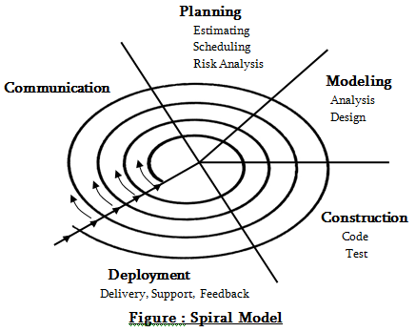

Spiral model is an evolutionary software process model which is a combination of an iterative nature of prototyping and controlled and systematic aspects of traditional waterfall model.

This model was originally proposed by Boehm. It provides the potential for rapid development of incremental versions of the software.

In a Spiral model, software development takes place in series of developed releases. In initial stage iterations, the release or model might be a paper model or a prototype. In the later stages, a complete version of software is produced.1. Customer communication tasks required establishing effective communication between developer and customer.

2. Planning-tasks required defining resources, timelines and other project related information.

3. Risk analysis tasks required to assess both technical and management risks.

Engineering tasks required building one or more representations of the application.

4. Construction and release tasks required to construct, test, install, and provide user support.

5. Customer evaluation-tasks required to obtain customer feedback based on an evaluation of the software representations created during the engineering stage and implemented during the installation stage.

**3.2 TIMELINE CHART**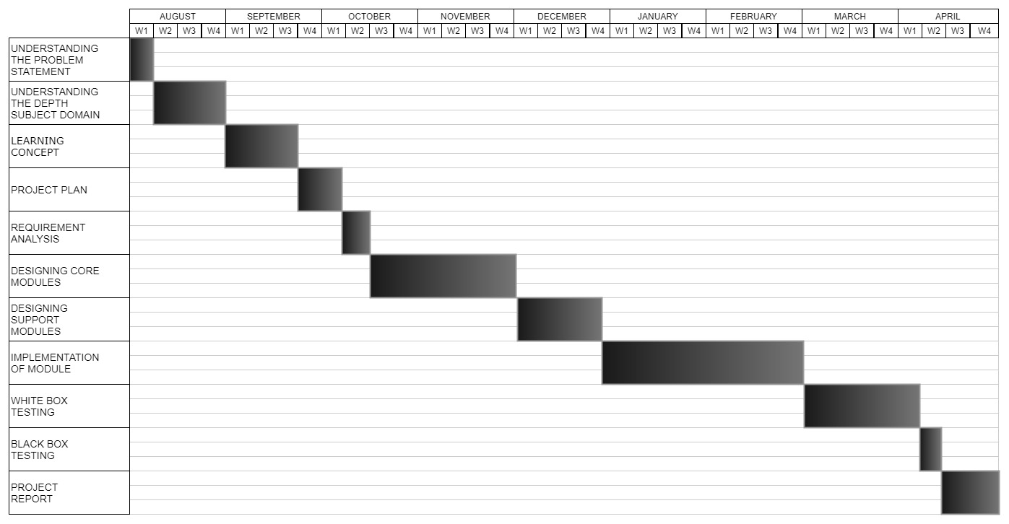

**3.3 FEASIBILITY STUDY**

Feasibility study is made to see if the project on completion will serve the purpose of the organization for the amount of work, effort and the time that spend on it. Feasibility study lets the developer foresee the future of the project and the usefulness. A feasibility study of a system proposal is according to its workability, which is the impact on the organization, ability to meet their user needs and effective use of resources. Thus when a new application is proposed it normally goes through a feasibility study before it is approved for development.

The document provide the feasibility of the project that is being designed and lists various areas that were considered very carefully during the feasibility study of this project such as Technical, Economic and Operational feasibilities.

**3.3.1 TECHNICAL FEASIBILITY**

The system must be evaluated from the technical point of view first. The assessment of this feasibility must be based on an outline design of the system requirement in the terms of input, output, programs and procedures. Having identified an outline system, the investigation must go on to suggest the type of equipment, required method developing the system, of running the system once it has been designed.

* Technical issues raised during the investigation are:
* Does the existing technology sufficient for the suggested one?
* Can the system expand if developed?

The project should be developed such that the necessary functions and performance are achieved within the constraints. The project is developed within latest technology. Through the technology may become obsolete after some period of time, due to the fact that never version of same software supports older versions, the system may still be used. So there are minimal constraints involved with this project. The system has been developed using Java the project is technically feasible for development

**3.3.2 ECONOMIC FEASIBILITY**

The developing system must be justified by cost and benefit. Criteria to ensure that effort is concentrated on project, which will give best, return at the earliest. One of the factors, which affect the development of a new system, is the cost it would require.

The following are some of the important financial questions asked during preliminary investigation:

* The costs conduct a full system investigation.
* The cost of the hardware and software.
* The benefits in the form of reduced costs or fewer costly errors.

Since the system is developed as part of project work, there is no manual cost to spend for the proposed system. Also all the resources are already available, it give an indication of the system is economically possible for development.

**3.3.3 BEHAVIORAL FEASIBILITY**

This includes the following questions:

* Is there sufficient support for the users?
* Will the proposed system cause harm?

The project would be beneficial because it satisfies the objectives when developed and installed. All behavioural aspects are considered carefully and conclude that the project is behaviourally feasible.

**RISK ANALYSIS PROCESS**

Regardless of the prevention techniques employed, possible threats that could arise inside or outside the organization need to be assessed. Although the exact nature of potential disasters or their resulting consequences are difficult to determine, it is beneficial to perform a comprehensive risk assessment of all threats that can realistically occur to the organization. Regardless of the type of threat, the goals of business recovery planning are to ensure the safety of customers, employees and other personnel during and following a disaster.

The relative probability of a disaster occurring should be determined. Items to consider in determining the probability of a specific disaster should include, but not be limited to: geographic location, topography of the area, proximity to major sources of power, bodies of water and airports, degree of accessibility to facilities within the organization, history of local utility services, history of the area’s susceptibility to natural threats, proximity to major highways which transport hazardous waste and combustible products. Potential exposures may be classified as natural, technical, or human threats. Examples include:

* Natural Threats: internal flooding, external flooding, internal fire, external fire, seismic activity, high winds, snow and ice storms, volcanic eruption, tornado, hurricane, epidemic, tidal wave, typhoon.
* **Technical Threats:** power failure/fluctuation, heating, ventilation or air conditioning failure, malfunction or failure of CPU, failure of system software, failure of application software, telecommunications failure, gas leaks, communications failure, nuclear fallout.
* Human Threats: robbery, bomb threats, embezzlement, extortion, burglary, vandalism, terrorism, civil disorder, chemical spill, sabotage, explosion, war, biological contamination, radiation contamination, hazardous waste, vehicle crash, airport proximity, work stoppage (Internal/External), computer crime.

1= Noticeable impact, interruption in operations for up to 8 hours,

2= Damage to equipment and/or facilities, interruption in operations for 8 - 48 hours,

3= Major damage to the equipment and/or facilities, interruption in operations for more than 48 hours.

All main office and/or computer centre functions must be relocated. Certain assumptions may be necessary to uniformly apply ratings to each potential threat.

Following are typical assumptions that can be used during the risk assessment process:

Although impact ratings could range between 1 and 3 for any facility given a specific set of circumstances, ratings applied should reflect anticipated, likely or expected impact on each area

2. Each potential threat should be assumed to be “localized” to the facility being rated.

3. Although one potential threat could lead to another potential threat (e.g., a hurricane could spawn tornados), no domino effect should be assumed.

4. If the result of the threat would not warrant movement to an alternate site(s), the impact should be rated no higher than a “2.”

5. The risk assessment should be performed by facility. To measure the potential risks, a weighted point rating system can be used.

**3.4 FUNCTIONAL AND NON-FUNCTIONAL REQUIREMENTS**

**3.4.1 Functional requirement**

In software engineering, a functional requirement defines a function of a software system or its component. A function is described as a set of inputs, the behaviour, and outputs. Functional requirements may be calculations, technical details, data manipulation and processing and other specific functionality that define *what* a system is supposed to accomplish. Behavioral requirements describing all the cases where the system uses the functional requirements are captured in use cases. Functional requirements are supported by non-functional requirements, which impose constraints on the design or implementation. The plan for implementing *functional* requirements is detailed in the system *design*. The plan for implementing *non-functional* requirements is detailed in the system *architecture*. As defined in requirements engineering, functional requirements specify particular results of a system. This should be contrasted with non-functional requirements which specify overall characteristics such as cost and reliability.

**3.4.2 Non-functional requirement**

In systems engineering and requirements engineering, a non-functional requirement is a requirement that specifies criteria that can be used to judge the operation of a system, rather than specific behaviours. This should be contrasted with functional requirements that define specific behaviour or functions. The plan for implementing *functional* requirements is detailed in the system design. The plan for implementing *non-functional* requirements is detailed in the system architecture

In general, functional requirements define what a system is supposed to *do* whereas non-functional requirements define how a system is supposed to *be*.

Non-functional requirements are often called qualities of a system. Other terms for non -functional requirements are "constraints", "quality attributes", "quality goals", "quality of service requirements" and "non-behavioral requirements".

CHAPTER 4

**REQUIREMENTS ANALYSIS**

## **4. REQUIREMENTS ANALYSIS**

**4.1 RISK ANALYSIS**

Risk we faced in first approach was that as we started using flex sensors ,the sending the data to unity engine via Serial communication .If we send data directly, which resulted in data overflow i.e., unity Engine didn't have the enough size to handle the entire series of data.Another risk we faced was ,every flex sensors have different range so we needed to get the value close enough to each other so that they could be used ,we used map() function to solve it but didn't work the way we wanted and resulted in inconsistency of data.

Also while using mpu6050 we had error like Rx/Tx, this was due to the use of Two Arduino Uno using as master slave. Using DMP for mpu6050 we needed an Higher baud rate i.e., at 115200, which resulted in FIFO overflow in DMP (Digital Motion Processing).During the first approach sending Digital signal back to unity wasn't easy because we were using the same function to read from Rx/Tx pins, So Arduino wasn't sure which data to read at a particular state, so we had inconsistence data, which resulted in error to get Haptic feedback.

During the second Approach instead of using 2 Arduino Uno we used one for both the MPU6050 which solves the above Rx/Tx error, but due to using DMP for both the mpu6050 the data we were getting is not consistency and Resulted in FIFO overflow so we couldn't use those data in Unity for hand motions. By doing the second Approach, the error of Rx/Tx pins got solved.

|  |  |
| --- | --- |
| **RISK SOURCE** | **DESCRIPTION** |
| Flex Sensors Error | Due to use of different flex sensors, they all have different values. |
| MPU6050 DPM error | Due to using DMP on both MPU6050 Fifo overflow occurred. |
| Rx/Tx pin Error | Due to use of same function Serial.Read() inconsistency of data occurred. |

**4.2 System Requirements**

**4.2.1 HARDWARE REQUIREMENTS**

* **Flex Sensors 2.2 Inches:**

A simple flex sensor 2.2" in length. As the sensor is flexed, the resistance across the sensor increases. The resistance of the flex sensor changes when the metal pads are on the outside of the bend (text on inside of bend).Connector is 0.1" spaced and bread board friendly.

* **Gyroscope MPU 6050:**

MPU6050 sensor module is complete 6-axis Motion Tracking Device. It combines 3-axis Gyroscope, 3-axis Accelerometer and Digital Motion Processor all in small package. Also, it has additional feature of on -chip Temperature sensor. It has I2C bus interface to communicate with the microcontrollers. It has Auxiliary I2C bus to communicate with other sensor devices like 3-axis Magnetometer, Pressure sensor etc. If 3-axis Magnetometer is connected to auxiliary I2C bus, then MPU6050 can provide complete 9-axis Motion Fusion output.

* **Arduino Uno R3 with USB:**

Arduino Uno is a microcontroller board based on the ATmega328P (datasheet). It has 14 digital input/output pins (of which 6 can be used as PWM outputs), 6 analog inputs, a 16 MHz quartz crystal, a USB connection, a power jack, an ICSP header and a reset button. It contains everything needed to support the microcontroller; "Uno" means one in Italian and was chosen to mark the release of Arduino Software (IDE) 1.0. The Uno board and version 1.0 of Arduino Software (IDE) were the reference versions of Arduino, now evolved to newer releases. The Uno board is the first in a series of USB Arduino boards, and the reference model for the Arduino platform; for an extensive list of current, past or outdated boards see the Arduino index of boards.

* **2k,5k,10k Ohms register:**

Resistors are electronic components which have a specific, never-changing electrical resistance. The resistor’s resistance limits the flow of electrons through a circuit. They are passive components, meaning they only consume power. Resistors are usually added to circuits where they complement active components like op-amps, microcontrollers, and other integrated circuits. Commonly resistors are used to limit current, divide voltages, and pull-up I/O lines.

* **Jumper Cable:**

​A jump wire (also known as jumper, jumper wire,jumper cable, DuPont wire, or DuPont cable – named for one manufacturer of them) is an electrical wire, or group of them in a cable, with a connector or pin at each end (or sometimes without them – simply "tinned"), which is normally used to interconnect the components of a breadboard or other prototype or test circuit, internally or with other equipment or components, without soldering. Individual jump wires are fitted by inserting their "end connectors" into the slots provided in a breadboard, the header connector of a circuit board, or a piece of test equipment.

* **Servo Motor:**

A servomotor is a rotary actuator or linear actuator that allows for precise control of angular or linear position, velocity and acceleration. It consists of a suitable motor coupled to a sensor for position feedback. It also requires a relatively sophisticated controller, often a dedicated module designed specifically for use with servomotors. Servomotors are not a specific class of motor although the term servomotor is often used to refer to a motor suitable for use in a closed-loop control system. Servomotors are used in applications such as robotics, CNC machinery or automated manufacturing.

* **Vibrating Motor:**

A vibrator is a mechanical device to generate vibrations. The vibration is often generated by an electric motor with an unbalanced mass on its driveshaft. Typically, they are components of larger products such as smartphones, pagers, or video game controllers with a "rumble" feature.

**4.2.2 SOFTWARE REQUIREMENTS**

* **Unity 3D:**

Unity is a cross-platform game engine developed by Unity Technologies, first announced and

released in June 2005 at Apple Inc.'s Worldwide Developers Conference as an OS X-exclusive

game engine. As of 2018, the engine has been extended to support 27 platforms. The engine can be

used to create both three-dimensional and two-dimensional games as well as simulations for

desktops and laptops, home consoles, smart TVs, and mobile devices. Several major versions of

Unity have been released since its launch, with the latest stable version being Unity 2018.2.8,

released on September 14, 2018.

* **Blender:**

The Blender Game Engine is a component of Blender, a free and open-source 3D production suite,

used for making real-time interactive content. The game engine was written from scratch in C++ as

a mostly independent component, and includes support for features such as Python scripting and

Open AL 3D sound.

* **UE4:**

The Unreal Engine is a source-available game engine developed by Epic Games, first showcased in

the 1998 first-person shooter game Unreal. Although primarily developed for first-person shooters,

it has been successfully used in a variety of other genres, including stealth, fighting games,

MMORPGs, and other RPGs. With its code written in C++, the Unreal Engine features a high

degree of portability and is a tool used by many game developers.

* **CINEMA4D:**

CINEMA 4D is a 3D modelling, animation, motion graphic and rendering application developed by

MAXON Computer GmbH in Germany. It is capable of procedural and polygonal/subd modelling,

animating, lighting, texturing, rendering, and common features found in 3D modelling applications.

* **ARDUINO IDE:**

Arduino is an open-source hardware and software company, project and user community that designs

and manufactures single-board microcontrollers and microcontroller kits for building digital devices

and interactive objects that can sense and control objects in the physical and digital world. Its

products are licensed under the GNU Lesser General Public License (LGPL) or the GNU General

Public License (GPL).

**4.5 Data Flow Diagrams**

**4.5.1 DFD Level 2**

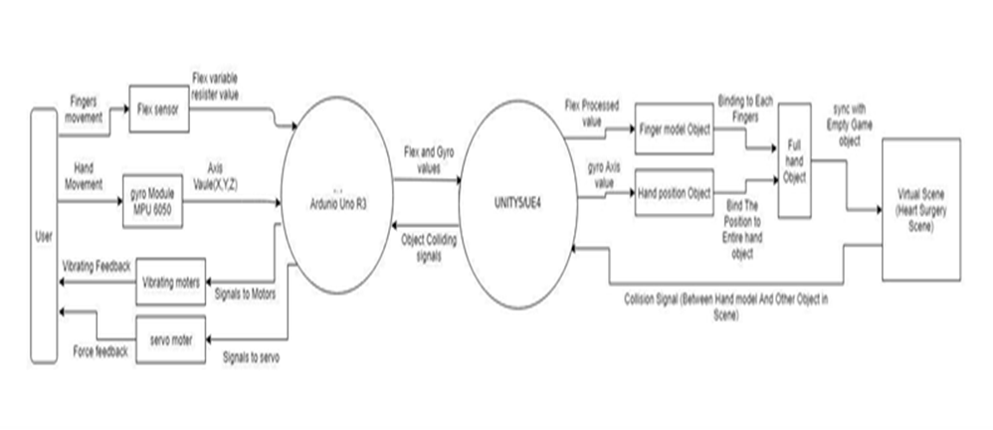

**Fig. Level 2 DFD**

**CHAPTER 5**

**PROPOSED SYSTEM**

**5. PROPOSED SYSTEM**

Possible users of the proposed Heart Surgery Simulation Using Haptic Gloves in Virtual Reality

range from entertainment to social and industrial applications. A description of user categories is given below. This system could further be used effectively and independently for different purposes such as follows:

* Control of consumer electronics
* Interaction with visualization system
* Control of mechanical systems
* Computer games

The main advantage of using this application is that one can use the VR Application for playing shooting games and one can help kids learn from them too using the interactive learning apps through which kids can grasp knowledge quiet easily, the second part of its application is that one can use in Medical field as in to practice and gain knowledge through it few of them are surgery simulation, interactive biological simulation and at last it can be used to help design as an sign language device, the third part of its use is in Music field where one can move his position to either play or pause music or to increase or decrease the volume or either to play different instruments and the final part of application is that one can design building models using CAD in VR to get to know how it will actually look in reality.

The scope of Haptic Gloves in VR is very vast in day-to-day technical solutions:

1. **HTC Vive:**

The HTC Vive is a virtual reality headset developed by HTC and Valve Corporation. The headset uses "room scale" tracking technology, allowing the user to move in 3D space and use motion-tracked handheld controllers to interact with the environment.

The Vive headset has a refresh rate of 90 Hz and a 110 degree field of view. The device uses two OLED panels, one per eye, each having a display resolution of 1080×1200 (2160×1200 combined pixels). Safety features include a front-facing camera that allows the user to observe their surroundings without removing their headset. The software can also use the camera to identify any moving or static objects in a room; this functionality can be used as part of a "Chaperone" safety system, which will automatically display a virtual wall or a feed from the camera to safely guide users from obstacles or real-world walls. Inside the headset's outer-shell divots are dozens of infrared sensors that detect the base stations' IR pulses to determine the head set's current location in a space. Other sensors include a G-Sensor, gyroscope and proximity sensor.

1. **SteamVR:**

SteamVR is a virtual reality system, with a headset built by Valve and partner HTC. The headset itself is called the HTC Vive. Like the Oculus Rift, the Vive is a VR device that contains two screens (1080x1200 resolution) streaming data at high refresh rates (90Hz) to create the sense of 3D virtual reality. Lenses sit between your eyes and the displays to create a rounded field of view and help your eyes focus on the LCDs. The headset will connect via a hardwire to a PC, which will run games and other VR software.

The HTC Vive headset is just one component that makes up SteamVR. The headset's position and orientation in space are tracked with a pair of laser-emitting base stations that Valve calls Lighthouse. Two base stations are placed in the corners of a room, and the lasers they emit make contact with sensors arranged around the surface of the Vive headset. The tracking system is extremely fast and precise, and can also be used to map the boundaries of a room, which can be incorporated into the VR experience. Stand close to the wall, and a representation of it can appear in front of you, preventing you from walking headfirst into it.

The third element of SteamVR is a pair of wand-shaped controllers Valve designed for VR games. The SteamVR controllers represent Nintendo Wii remotes with sensor arrays mounted on top of them for the same degree of positional tracking as seen in the headset. The controllers use haptic thumbpads that can be split into a number of "buttons" or directional inputs. A trigger on the back serves as the primary button.

SteamVR is the latest iteration of virtual reality hardware from Valve, after years of R&D and experimenting with different tracking options. Notably, while the Oculus Rift is still presented as primarily a seated experience, SteamVR is designed to support standing and walking around a room with full positional tracking.

**5.1.1 Basic Flowchart**

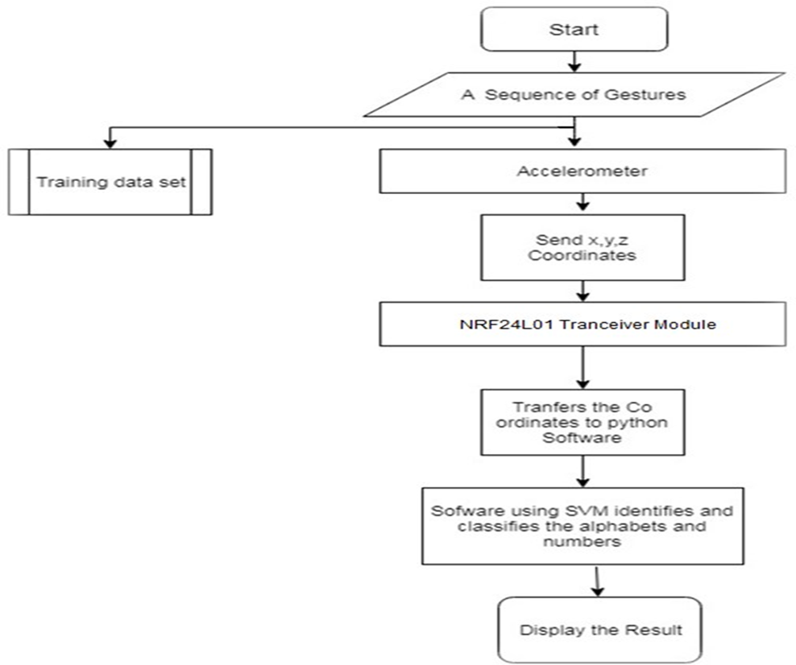

**Fig. 5.1.1 Flowchart for Heart Surgery Simulation using Haptic Gloves in**

**Virtual Reality**

**5.1.2 Use Case Diagram**

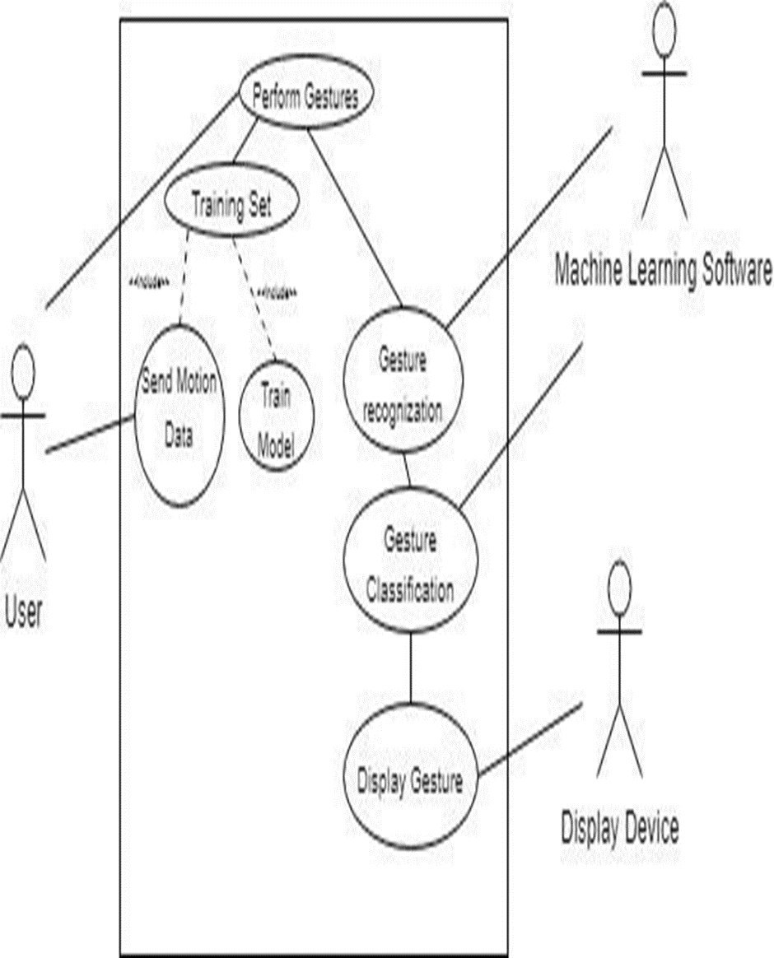

**Fig. 5.2.1 Use Case Diagram for Heart Surgery Simulation using Haptic Gloves in**

**Virtual Reality**

**5.1.3 Activity Diagram**

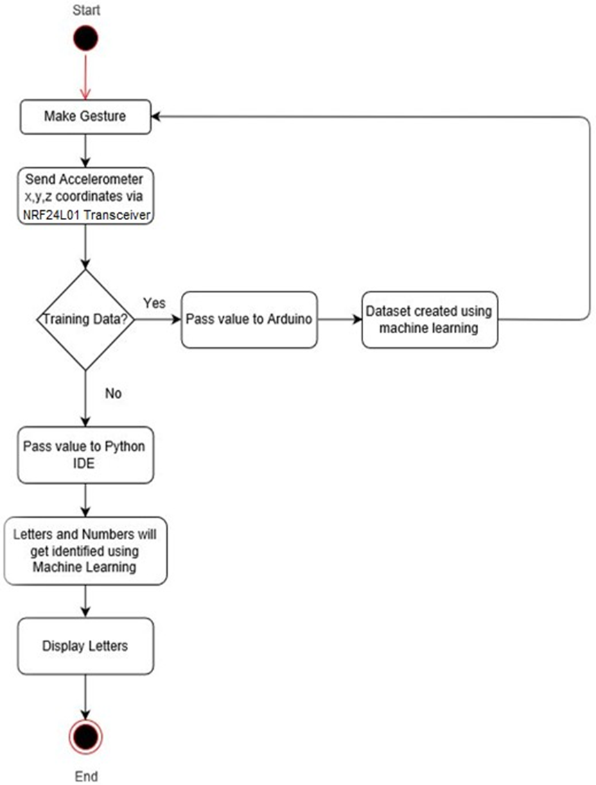

**Fig. 5.2.1 Activity Diagram of Heart Surgery Simulation using Haptic Gloves in Virtual Reality**

**5.1.4 Sequence Diagram**

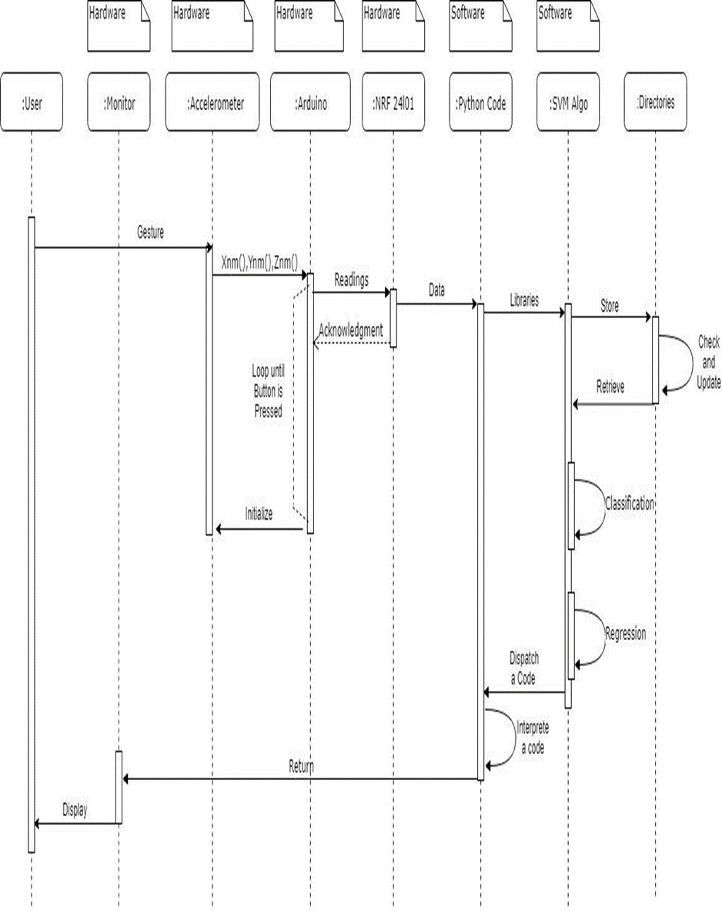

**Fig. 5.2.2 Sequence Diagram** **for Heart Surgery Simulation using Haptic Gloves in Virtual Reality**

**5.1.5 Class Diagram**

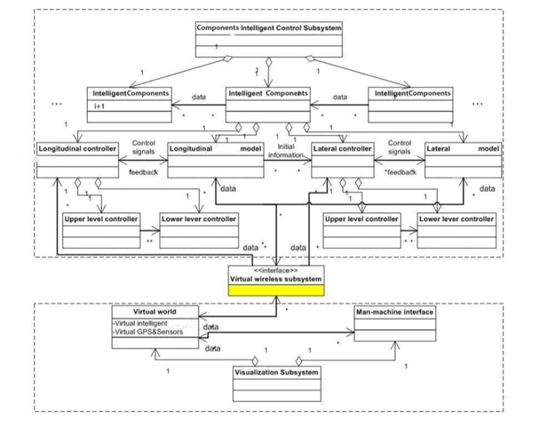

**Fig. 5.2.3 Class diagram for Heart Surgery Simulation using Haptic Gloves in Virtual Reality**

**5.1.6 Plugin Diagram**

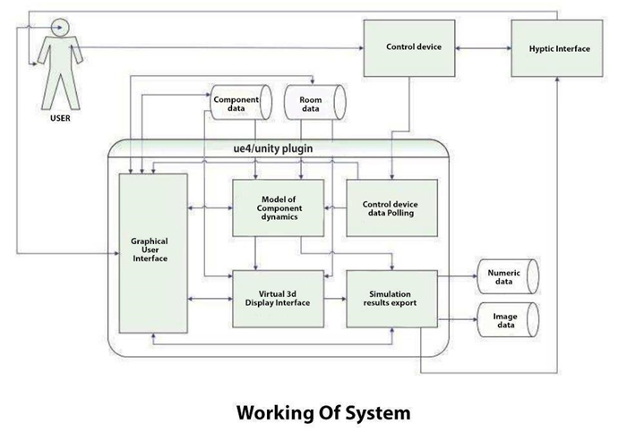

**Fig. 5.6 Plugin Diagram for Heart Surgery Simulation using Haptic Gloves in Virtual Reality**

**5.2 Algorithm Development**

Haptic interface devices an understanding of some basic concepts about haptic interface devices will help the reader through the remainder of the text. A more complete description of the elements that make up such systems is available elsewhere.1 haptic interface devices behave like small robots that exchange mechanical energy with a user. We use the term device-body interface to highlight the physical connection between operator and device through which energy is exchanged. Although these interfaces can be in contact with any part of the operator’s body, hand interfaces have been the most widely used and developed systems to date. Figure 2 shows some example devices. One way to distinguish between haptic interface devices is by their grounding locations. For interdigit tasks, force-feedback gloves, such as the Hand Force Feedback (HFF), 2 read finger-specific contact information and output finger-specific resistive forces, but can’t reproduce object net weight or inertial forces. Similar handheld devices are common in the gaming industry and are built using low-cost vibrotactile transducers, which produce synthesized vibratory effects. Exoskeleton mechanisms or body-based haptic interfaces, which a person wears on the arm or leg, present more complex multiple degree-of-freedom (DOF) motorized devices. Finally, ground-based devices include force-reflecting joysticks and desktop haptic interfaces.

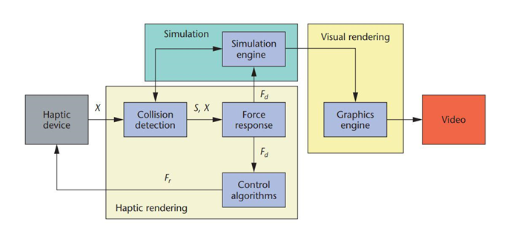

We split haptic rendering into three main blocks. Collision-detection algorithms provide information about contacts S occurring between an avatar at position X and objects in the virtual environment. Force-response algorithms return the ideal interaction force Fd between avatar and virtual objects. Control algorithms return a force Fr to the user approximating the ideal interaction force to the best of the device’s capabilities.

* **Geometry-dependent force-rendering algorithms:**

The first type of force-rendering algorithms aspires to recreate the force interaction a user would feel when touching a frictionless and texture less object. Such interaction forces depend on the geometry of the object being touched, its compliance, and the geometry of the avatar representing the haptic interface inside the virtual environment. Although exceptions exist,5 the DOF necessary to describe the interaction forces between an avatar and a virtual object typically matches the actuated DOF of the haptic device being used. Thus for simpler devices, such as a 1-DOF force-reflecting gripper (Figure 2a), the avatar consists of a couple of points that can only move and exchange forces along the line connecting them. For this device type, the force-rendering algorithm computes a simple 1-DOF squeeze force between the index finger and the thumb, similar to the force you would feel when cutting an object with scissors. When using a 6-DOF haptic device, the avatar can be an object of any shape. In this case, the force-rendering algorithm computes all the interaction forces between the object and the virtual environment and applies the resultant force and torque vectors to the user through the haptic device. We group current force-rendering algorithms by the number of DOF necessary to describe the interaction force being rendered.

* **Surface property-dependent force-rendering algorithms:**

All real surfaces contain tiny irregularities or indentations. Obviously, it’s impossible to distinguish each irregularity when sliding a finger over an object. However, tactile sensors in the human skin can feel their combined effects when rubbed against a real surface. Although this article doesn’t focus on tactile displays, we briefly present the state of the art for algorithms that can render virtual objects’ haptic textures and friction properties. Micro-irregularities act as obstructions when two surfaces slide against each other and generate forces tangential to the surface and opposite to motion. Friction, when viewed at the microscopic level, is a complicated phenomenon. Nevertheless, simple empirical models exist, such as the one Leonardo da Vinci proposed and Charles Augustin de Coulomb later developed in 1785. Such models served as a basis for the simpler frictional models in 3 DOF.14, 15 Researchers outside the haptic community have developed many models to render friction with higher accuracy—for example, the Karnopp model for modelling stick-slip friction, the Bristle model, and the reset integrator model. Higher accuracy, however, sacrifices speed, a critical factor in real-time applications. Any choice of modelling technique must consider this trade off. Keeping this trade off in mind, researchers have developed more accurate haptic-rendering algorithms for friction (see, for instance, Dupont et al.25). A texture or pattern generally covers real surfaces. Researchers have proposed various techniques for rendering the forces that touching such textures generates. Many of these techniques are inspired by analogous techniques in modern computer graphics. In computer graphics, texture mapping adds realism to computer-generated scenes by projecting a bitmap image onto surfaces being rendered. The same can be done haptically. Minsky11 first proposed haptic texture mapping for 2D; Ruspini et al. later extended his work to 3D scenes.15 Researchers have also used mathematical functions to create synthetic patterns. Basdogan et al.22 and Costa et al.26 investigated the use of fractals to model natural textures while Siira and Pai27 used a stochastic approach.

**CHAPTER 6**

**IMPLEMENTATION**

**6. IMPLEMENTATION**

**6.1 SCREENSHOTS**

**1.** When flex sensor and 2 MPU 6050 is connected and where 1 MPU is running on DMP Processor and the other is using Complimentary Filter for processing.

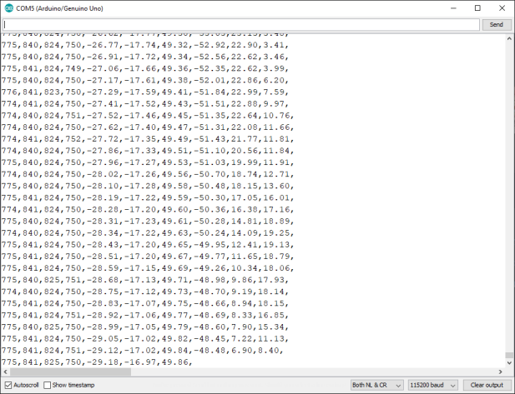

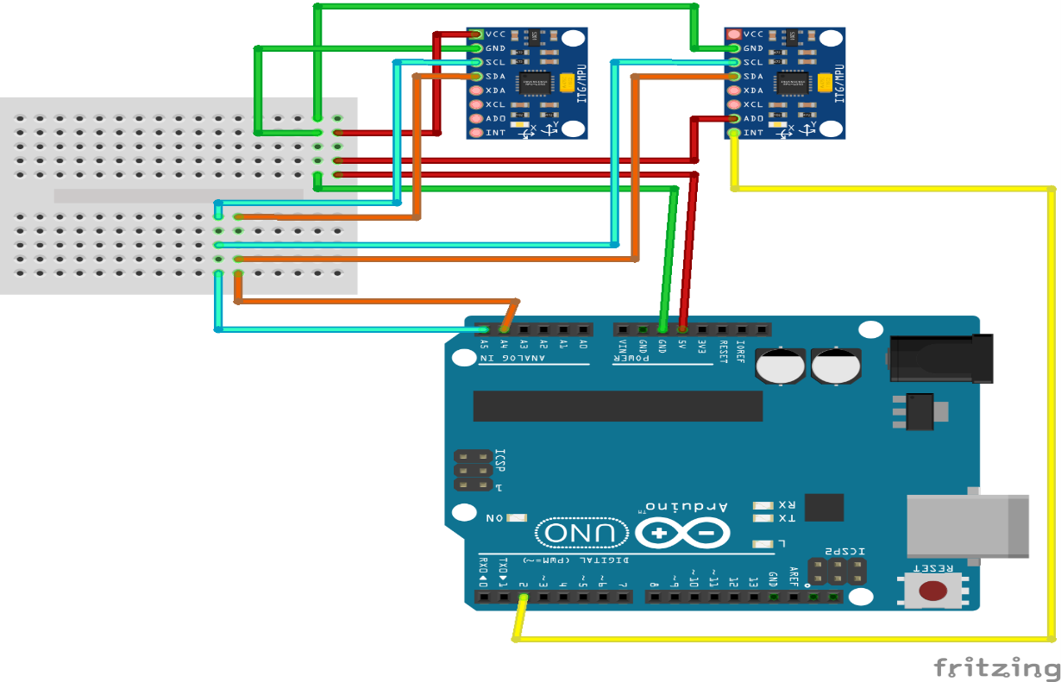

**2.** Accurate Flex Sensor Value (Degree)

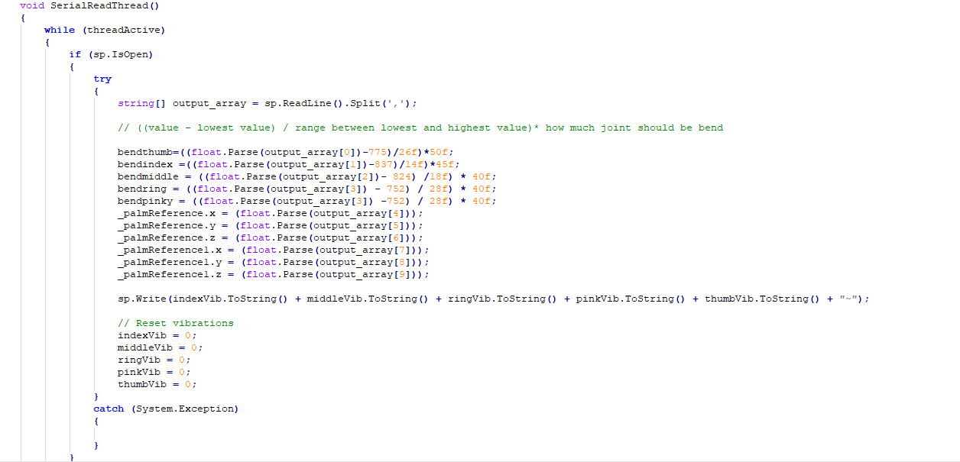

**3.** Complete Circuit Diagram

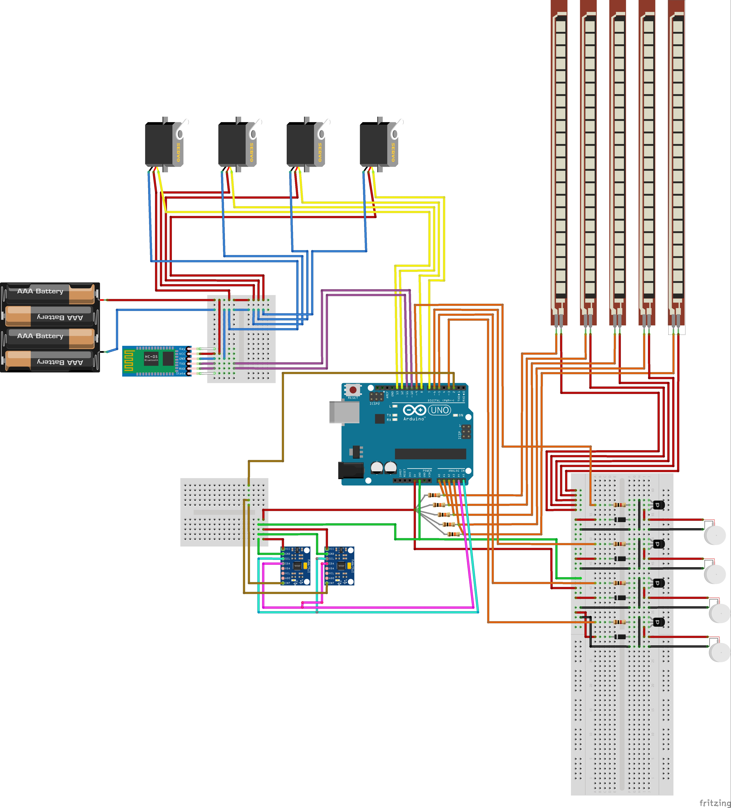

**CHAPTER 7**

**RESULT AND DISCUSSION**

**7. RESULT AND DISCUSSION**

**1.** Heart Surgery simulation being performed in Virtual Reality with help of Unity Engine

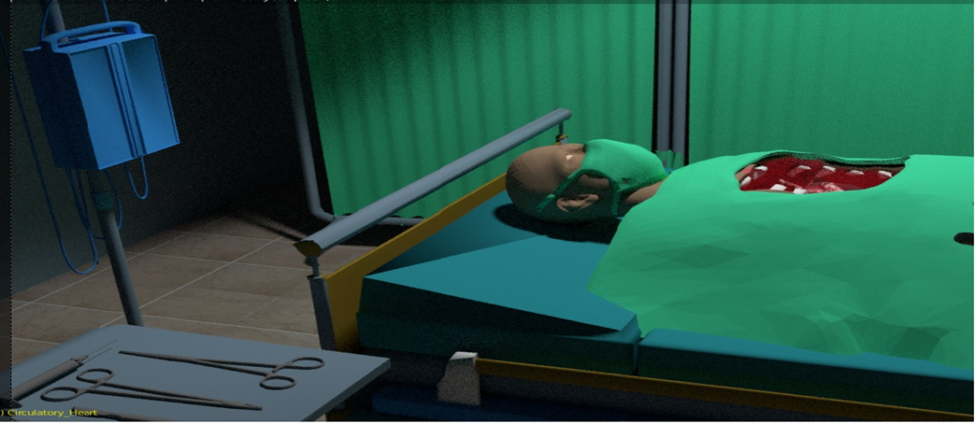

**2.** Haptic Gloves wore through which we can perform Heart Surgery in Virtual Reality

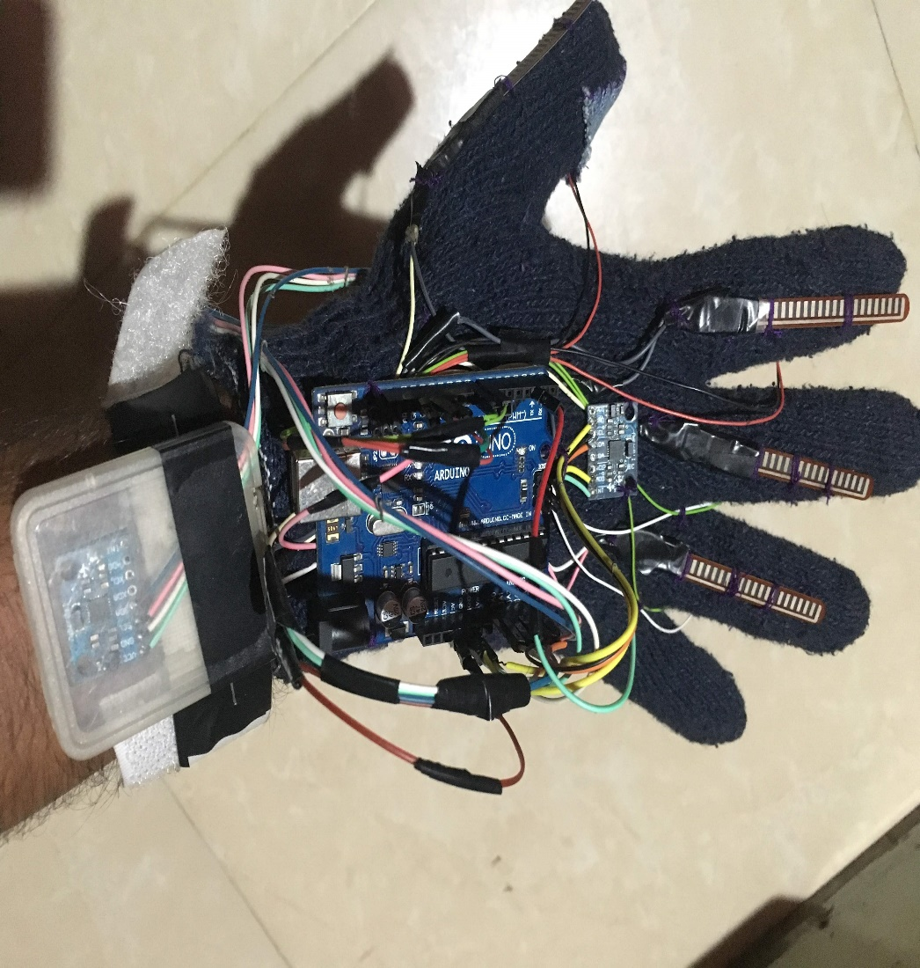

**CHAPTER 8**

**CONCLUSION**

**8. CONCLUSION**

**8.1 CONCLUSION**

As haptics moves beyond the buzzes and thumps of today’s video games, technology will enable increasingly believable and complex physical interaction with virtual or remote objects. Already haptically enabled commercial products let designers sculpt digital clay figures to rapidly produce new product geometry, museum goers feel previously inaccessible artifacts, and doctors train for simple procedures without endangering patients. Past technological advances that permitted recording, encoding, storage, transmission, editing, and ultimately synthesis of images and sound profoundly affected society. A wide range of human activities, including communication, education, art, entertainment, commerce, and science, were forever changed when we learned to capture, manipulate, and create sensory stimuli nearly indistinguishable from reality. It’s not unreasonable to expect that future advancements in haptics will have equally deep effects. Though the field is still in its infancy, hints of vast, unexplored intellectual and commercial territory add excitement and energy to a growing number of conferences, courses, product releases, and invention efforts.

* 1. **FUTURE SCOPE**
  2. **VR Application:**
* Shooting Games
* Interactive Learning Apps
  1. **Medical:**
* Surgery Simulation
* Interactive Biological Simulation
* Can be used to help design sign language device

* 1. **Music:**
* Can be used to play different instruments
  1. **CAD Architectural Design and Art:**
* Designing the building models
* Art in VR

**REFERENCES**

[1] G. Burdea, “Force and touch feedback for virtual reality”, A Wiley-Inter science Publication, 1996.

[2] Iman Brouwer1, Karon Mac Lean2, Antony Hodgson1 “How Cheap Can We Make a High Quality VR Surgical Simulator?” ME, 2CS Department, University of British Columbia, 2003

[3] Paula Waddingham, Sarah Sharples “State of the art update of Haptic devices, University of Nottingham, ©SATIN Consortium Members, 2007.

[4] Seungmoon Choi, Ph.D. “Introduction to haptics” Virtual Reality and Perceptive Media Laboratory Dept. of Computer Science and Engineering POSTECH, Spring 2007.www.postech.ac.kr/~choism/courses/advanced computer Haptics

[5] Jeffrey J. Berkley “Haptic Devices” White Paper prepared by: Mimic Technologies Inc. 4033 Aurora Ave N. Suite 201 Seattle, WA 98103, May, 2003.

[6] Monica Bordegoni (Politecnico di Milano) “Haptic technology” 2005 T’nD Consortium Members.

[7] Mandayam A. Srinivasan “What is Haptcs?”Laboratory for Human and Machine Haptics: The Touch Lab Massachusetts Institute of Technology 2005 http://touchlab.mit.edu

http://www.sklab-www.pi.titech.ac.jp/~seahak/vr.html

http://www.yantric.com/products.html http://www.spacemart.com/reports/Welcome_To_The_World_Of_Haptics_For_Ind ustrial_Applications_999.html

http://www.cs.utah.edu/~tthompso/haptics.html

http://www.roblesdelatorre.com/gabriel/hapticsl

**ACKNOWLEDGEMENTS**

It is pleasant task to express gratitude to all those who contributed in many ways to this project and made it an unforgettable experience for us. First of all, we would like to thank our guide Prof. Deepti Vijay Chandran. This work would not have been possible without her guidance, support and encouragement.

We are highly indebted to Dr. Sunil Chavan, Principal, **Smt. Indira Gandhi College of Engineering**, Dr. K. T. Patil, Head of the Department, **Computer Department** and also all the faculty members.

We are thankful to lord for keeping us energized that every end seems to be new beginning.

**HEART SURGERY SIMULATION USING HAPTIC GLOVES IN VIRTUAL REALITY**

|  |  |  |  |
| --- | --- | --- | --- |
| RAHUL ANAND | ANURAG SINGH | SUDHIR YADAV | DEEPTI CHANDRAN |
| Smt.Indira Gandhi College of Engineering  Navi Mumbai  (400709) | Smt.Indira Gandhi  College of  Engineering  Navi Mumbai  (400709) | Smt.Indira Gandhi  College of  Engineering  Navi Mumbai  (400709) | Smt.Indira Gandhi  College of  Engineering  Navi Mumbai  (400709) |
| rahulanandx  @gmail.com | anuragsingh9975  @gmail.com | sudhir9297  @gmail.com |  |

***Abstract—Humans are capable of haptically perceiving the shape of an object by simply wielding it, even without seeing it. On the other hand, typical hand-held controllers for virtual reality (VR) applications are pre-designed for general applications, and thus not capable of providing appropriate haptic shape perception when wielding specie virtual objects. Contradiction between haptic and visual shape perception causes a lack of immersion and leads to inappropriate object handling in VR. To solve this problem, we propose a novel method for designing hand-held VR controllers which illusorily represent haptic equivalent of visual shape in VR. In ecological psychology, it has been suggested that the perceived shape can be modelled using the limited mass properties of wielded objects. Based on this suggestion, we built a shape perception model.***

***Using a data-driven approach; we aggregated data of perceived shapes against various hand-held VR controllers with dierent mass properties, and derived the model using regression techniques. We implemented a design system which enables automatic design of hand-held VR controllers whose actual shapes are smaller than target shapes while maintaining their haptic shape perception.***

***Keywords- haptically, VR controllers, perception, data driven approach, virtual objects***

I. INTRODUCTION

Presently, many types of training are made already in virtual reality (VR) environ. In these ambient users can undergo tasks involving human risks or else critical, like military combat strategies or else surgeries. Some authors recommend the training simulators usage in the medicinal field for enhancing physician training with assessment, that could provide more security for patients and also in the health care method [4].In such case, the scientific literature evidenced that training based on VR enhances individual medical talents [6].Thus, environments of realistic virtual reality have been built by training objectives for immersing the user within a virtual world in which simulations of actual situations can be done.[2] For several health care professionals, VR has first place among all technology. The VR is demonstrated as an accumulation of the technological devices: a computer having the ability of interactive 3D visualization, a head-mounted display plus data gloves supplied with one or more position trackers. Here, the trackers assume the position, the sense and orientation of the user and inform that information of the computer renovates the images to display. Anyhow, the variant VR applications analysis vividly presents that the aim on technological devices is variant based on health care provider development [7,9].Though there is a few proof presenting such simulators, it can proffer the required training quality and verifying, their profile of cost makes them inappropriate for usage by student populations who are outside of their facility of training [10]. We should reassess the VR role in surgical training plus planning due to rapid enhancement of virtual reality and due to rapid moving of the new technology into the operating room. the virtual [3,8] reality system utilizing computer picture of the past, the maturity of hardware level , the appropriate originals have been fixed, the developers desire make original of your own is very tough, if foreign purchases of words, dozens s image, it will have cost a few million, and hence, it is for preparing the corresponding spot of a different typed of hardware, Hence it is very tough and very costly. Moreover, big -performance equipment delivery also needs distinctive technical knowledge [1,5]. Hence, Systems of virtual reality systems for the Neuro computer graphics packages are having no cost, fixed equipment is tiny, unique requirements of the patient are minimized greatly, there is no need addressing many computer graphics expertise virtual reality system requirements is not required as it augments constantly [9,11].

II.VIRTUAL REALITY AND TRAINING

Virtual Reality denotes to actual-time systems represented by computer graphics which permit the user interaction with movements with three or else more grades of liberty [11]. Virtual Reality, more than a technology, evolved as new science which integrates many areas as computers, graphics, cognition and engineering. Worlds of Virtual reality are 3D environments generated through computer graphics methods in which one or more users are involved partially or completely for communicating with virtual factors. The special of the experience of the user in a virtual reality world is provided through the graphics resolution and also by the distinctive devices usage for communication. Fundamentally, the devices revitalize human senses like the sight, hearing and the touch [15, 17]. Several purposes are there for virtual reality systems, yet a very significant one is the initiation of training methods. Training simulation offers vital advantageous over other techniques, importantly in complicated procedures where the human life or else large financial resources are participated. In the following Figure 1, the virtual reality simulator can be observed and the evaluation system is independent, yet performs simultaneously. The user’s communications with the system are observed and the information is delivered to the evaluator system which evaluates the data and effuses a report on the performance of the user at the final period of the training. Typically, an online analysis system must be effective to observe the virtual environment simulation. For that is necessary to Accumulating information offered by by the environment and by the user communication is required for that, like positions, forces, torque, speeds, resistance, accelerations, visualization ,temperatures, and/or visualization angle, smells ,sounds, and etc. This information is utilized for feeding the evaluation system [18].



Fig. Diagram of the complete system: Virtual Reality Simulator and Evaluation System. Based on the application, every variable or a few of them will be observed as per their appropriateness to the training.

III. HAPTIC FEEDBACK INTERFACES

Haptic feedback interfaces comprise force feedback and tactile feedback devices. Force feedback interfaces can be viewed as computer “extensions” that apply physical forces, and torques on the user. The interfaces that are most used today are those that are desk-top, are easy to install, clean and safe to the user. When comparing force feedback hardware for a given simulation application, such as CAD/CAM, the designer has to consider several key hardware characteristics. These are the number of degrees of freedom, the interface work envelope, its maximum vs. sustained force levels, its structural friction and stiffness, its dynamic range, control bandwidth, etc. Sustained force levels are usually much smaller than maximum output force produced by haptic interfaces. This is especially true for forces produced with electrical actuators, which overheat. Friction needs to be small, such that the forces commanded by the computer are not “filtered out” by the interface, before they are felt by the user. Dynamic range is the maximum force divided by the interface friction. This a-dimensional number is a good measure of the quality of the force feedback produced by a given interface. Finally, high bandwidths are important for short time delays and overall system stability.

The ExoK’ab (K’ab being a Mayan word meaning "hand") presented in this study aims to design and develop a compact, light-weight solution, with independent motion on each phalange, complete position sensorization and the capability to exert forces that fulfil the specifications obtained in a preliminary ergonomic study on patients for particular rehabilitation protocols that demand position and force control.The system includes independent movements for flexion and extension; for comfort reasons, abduction-adduction movement is included but not actuated. It has the capacity to be adapted to different finger sizes and to accommodate different palm sizes, including the particular motion of knuckles. Due to it being completely sensorized, it measures each rotational and translational movement of the robot in order to control position in passive rehabilitation. It also provides the capability of measuring the force applied to the user in each phalange when active rehabilitation is required. It is also important to note that the present design was carried out taking into account a low-cost criterion and long-term mass production.

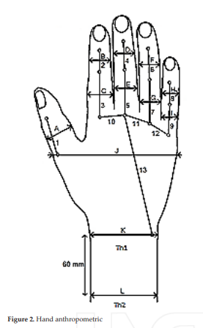

IV.EXPERIMENTAL DESIGN

The Arduino Atmega8 is used as the controller. Arduino is a brand of open-source microcontrollers frequently used in athome, do-it-yourself electronics projects. It can be programmed in a version of C, and the Arduino website contains software for programming the device. There are also a host of straightforward online tutorials that make it easy and quick to learn. A variety of electronic components can be connected via breadboard as inputs and outputs for the code, making Arduinos incredibly versatile. Arduino microcontrollers are intuitive, inexpensive, and readily available—three factors critical to accessible, easy-to-use prosthetics. The movement of robot fingers is controlled by Servo SG90. That is small and lightweight with high output power. Servo can rotate approximately 180 degrees (90 in each direction).

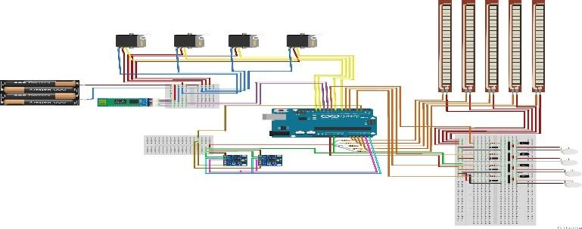

Fig. Model of Pros

The flex sensors are used to measure the bending of the fingers. When the sensor is flexed, the resistance across the sensor increases. The gyroscope is placed on the wrist and shoulder to track the position of the hand movements, when moved. The signals from the sensors are sent to Arduino to process and control the servo motor as showed in finger 4, that control the exoskeleton hand.

After attaching the tendon string‖ to the finger and threading it through all the narrow holes, the opening‘andclosing‘finger positions are marked. The distance the string travelled can be measured, and therefore how far the servo needed to travel to open and close each finger. This measurement would be used to find the servo travel angle in the code for each finger. An Arduino Atmega8 is used to control the servo motor to control the movement of fingers.

The void loop contains the variable pos (position). It is this one variable that is used to assess the condition to stay in or exit the loop, as well as incrementing/decrementing the counter. More importantly, this variable represents the servo position value for the myservo1.write(n) statement, where n is replaced with pos. As the loop runs, the pos value (which begin at 0) is incremented, and thus the position of the servo is changed one degree at a time by using the myservo1.write(pos) statement. The servo rotation is based on the code by using the time delay function delay() after each individual or group of write() position movements.

for(pos1 = 0; pos1 < 220; pos1 += 1)

{

myservo1.write(pos1); // Finger1(pinky)

delay(5);

}

The vibrating motors provide the necessary vibrations when an object is touched or collided in a virtual world so that the user can feel it when the vibrating motor gives those vibrating sensations.

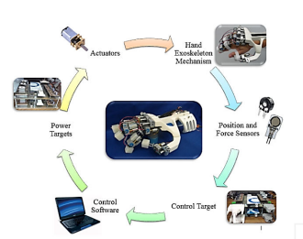

Fig. Integrtion of the system

To create a scenic experience in VR, we are making use of Unity Game Engine to develop the scene of a clinic where the heart surgery is to be performed.

About Unity Game Engine:

Unity gives users the ability to create games in both 2D and 3D, and the engine offers a primary scripting API in C#, for both the Unity editor in the form of plugins, and games themselves, as well as drag and drop functionality.

Prior to C# being the primary programming language used for the engine, it previously supported Boo, which was removed in the Unity 5[7] release, and a version of JavaScript called UnityScript, which was deprecated in August 2017 after the release of Unity 2017.1 in favor of C#.[8] The engine has support for the following graphics APIs: Direct3D on Windows and Xbox One; OpenGL on Linux, macOS, and Windows; OpenGL ES on Android and iOS; WebGL on the web; and proprietary APIs on the video game consoles. Additionally, Unity supports the low-level APIs Metal on iOS and macOS and Vulkan on Android, Linux, and Windows, as well as Direct3D 12 on Windows and Xbox One.Within 2D games, Unity allows importation of sprites and an advanced 2D world renderer. For 3D games, Unity allows specification of texture compression, mipmaps, and resolution settings for each platform that the game engine supports,[5] and provides support for bump mapping, reflection mapping, parallax mapping, screen space ambient occlusion (SSAO), dynamic shadows using shadow maps, render-to-texture and full-screen post-processing effects.[9]Since about 2016 Unity also offers cloud-based services to developers, these are presently: Unity Ads, Unity Analytics, Unity Certification, Unity Cloud Build, Unity Everyplay, Unity IAP ("In app purchase" - for the Apple and Google app stores), Unity Multiplayer, Unity Performance Reporting, Unity Collaborate and Unity Hub.

Unity supports the creation of custom vertexes, fragments (or pixels), tessellation, compute shaders and Unity's own surface shaders using Cg, a modified version of Microsoft's High-Level Shading Language developed by Nvidia.

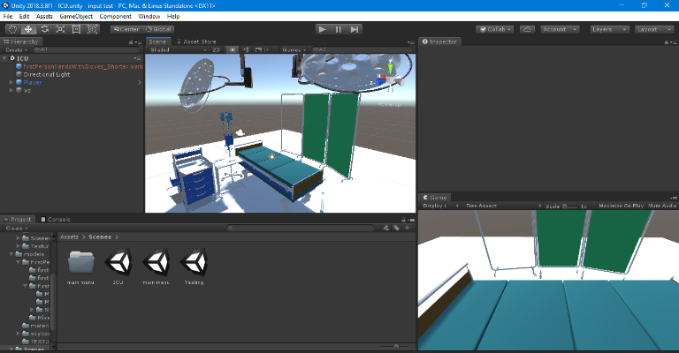

Fig. Development of ICU in Unity Game Engine to perform heart surgery in VR.

V.EXPERIMENT RESULTS

The flexion and extension of each finger on exoskeleton hand can be controlled by coding in Arduino through the fishing lines and the motion tracking direction is provided by Gyroscope and the servo motors provides the precision control of angular or linear position and the vibrating motor provides the vibrations often generated by electric motor with an unbalanced motor on its driveshaft.

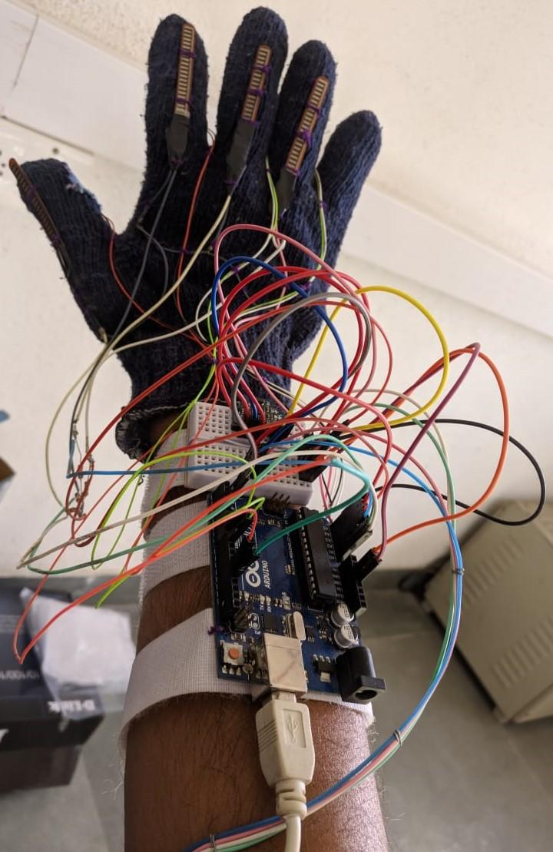

Fig. Complete Haptic Glove

VI. APPLICATIONS

Virtual environments have been created and used in many areas of medicine. Early developments in the surgical field soft tissue modelling have all been described. A series of dedicated conferences have sparked interest in this field, and reports on VR applications in medicine can be found in the medical, computer science, engineering, and popular lay literature. Both VR and VE applications in surgery can be subdivided as follows: training and education, surgical planning, image guidance, and tele-surgery.

A.Training and Education

The similarities between pilot and surgeon responsibilities are striking: both must be ready to manage potentially life-threatening situations in dynamic, unpredictable environments. The long and successful use of flight simulators in air and space flight training has inspired the application of this technology to surgical training.48 Perhaps because of the number of complications resulting from the uncontrolled growth of laparoscopic procedures in the early 1990s, many groups have pursued simulation of minimally invasive and endoscopic procedures. Tendick et al have developed laparoscopic camera handling and cholecystectomy simulations based on a graphics workstation, while Tseng et al have built a real-time force feedback cholecystectomy simulator based on a personal computer. Advances in tissue modelling, graphics, and haptic instrumentation have enabled the development of open abdominal and hollow-tube anastomosis simulators.

Initial validation studies using these and other simulators have shown differences between experienced and novice surgeons, that training scores improve over time, and that simulator task performance is correlated to actual task performance. Training applications for retinal, arthroscopic, neurosurgical, and otolaryngology procedures have also been described. Virtual reality technology has been used to create several learning environments.

B. Surgical Planning

Virtual reality technology can serve as a useful adjunct to traditional surgical planning techniques. Basic research in image processing and segmentation of computed tomography and magnetic resonance scans has enabled reliable 3D reconstructions of important anatomical structures. These 3D imaging data have been used to further understand complex anatomical relationships in specific patients prior to skull base surgery, and also to examine and display the microsurgical anatomy of the basilar artery bifurcation. Three-dimensional reconstructions have proven particularly useful in planning stereotactic and minimally invasive neurosurgical procedures. Modelling of deformable facial tissues has enabled simulation of tissue changes and the postoperative outcome of craniofacial surgery. Other soft tissue applications include planning liver resections on a 3D, deformable liver model with the aid of a virtual laparoscopic tool.

VII.ACKNOWLEDGEMENT

It is pleasant task to express gratitude to all those who

contributed in many ways to this project and made it an unforgettable experience for us. First of all we would like to thanks our guide Prof. Deepti Vijay Chandran. This work would not have been possible without her guidance, support and encouragement. We are highly intended to Dr. Sunil Chavan, Principal, Smt. Indira Gandhi College Engineering, Prof. K. T. Patil, Head of the Department, Computer Department and also the faculty members.

VIII.DISCUSSION & CONCLUSIONS

Though in its infancy, the field of VR and simulation in surgical education and training is gaining recognition. The Committee on Emerging Surgical Technology and Education of the American College of Surgeons sponsored a demonstration of various simulation and VR-based educational environments at the 1998 Clinical Congress, and reports on these evolving modalities are beginning to appear in the mainstream surgical literature.81The exact effect of this change on the surgical education process is impossible to predict, though evidence suggests positive outcomes will result. Adult learners seek to gain and understand skills and knowledge that will assist them in important activities. They learn by doing and are often most successful when the experience is self-directed.82 When focused on practical applications, the adult learner gains insight as information is placed within a contextual framework. Providing this context within a rich visual, auditory, and touch-enhanced virtual world has enabled the transfer of VR-based training to actual skill.83,84

Simulation as a metaphor for authentic experience was used prior to the advent of computerized simulations, with role-playing in business training, war games, and paramedical training. Well-designed computer simulations, though unable to teach per se, can provide the needed context that provides for optimal learning. Certain environments cannot be replicated without the assistance of computers (eg, space travel), necessitating the creation of manageable, low-risk, computer-based alternatives. Simulation provides effective learning experiences in groups or alone, can suit learners of varying backgrounds, is interactive and fun, and is more compelling because one can immediately see the consequences of one's actions.85 historically, mainstream educational systems have regarded learning as an individual process. Recent evidence suggests that doing so fails to prepare the learner for high achievement in the modern workplace, which is characterized by the need to successfully use technology to collect, analyse, and act on information.86 To counter this, group or collaborative learning is increasingly used as a networked learning environment to enable students to work together on learning tasks.

It is hoped that this brief discussion gave the reader a feel for the complexities and benefits of haptic interface in VR simulation, especially as they relate to CAD/CAM applications. While the need for haptics has become clear in recent years [Brooks, 1999], the technology is not fully developed. We need interfaces that are powerful, yet light and non-obstructive. This in turn requires novel actuators of the type that do not exist today. Distributed computation on multiple processors and multiple computers will become widespread, especially as higher bandwidth networks become common. This in turn will allow haptics to be added to today's web modalities of sight and sound. Once the hardware problems are solved, more and more work will be dedicated to making simulations more realistic. This will require significant human-factors studies for iterative design and validation. Haptics will also require more of the third I in VR, imagination.

REFERENCES

[l] G. Burdea, “Force and touch feedback for virtual reality”, A Wiley-Inter science Publication, 1996.

[2] Iman Brouwer1, Karon Mac Lean2, Antony Hodgson1 “How Cheap Can We Make a High Quality VR Surgical Simulator?” ME, 2CS Department, University of British Columbia, 2003

[3] Paula Waddingham, Sarah Sharples “State of the art update of Haptic devices, University of Nottingham, ©SATIN Consortium Members, 2007.

[4] Seungmoon Choi, Ph.D. “Introduction to haptics” Virtual Reality and Perceptive Media Laboratory Dept. of Computer Science and Engineering POSTECH, Spring 2007.www.postech.ac.kr/~choism/courses/advanced computer Haptics

[5] Jeffrey J. Berkley “Haptic Devices” White Paper prepared by: Mimic Technologies Inc. 4033 Aurora Ave N. Suite 201 Seattle, WA 98103, May, 2003.

[6] Monica Bordegoni (Politecnico di Milano) “Haptic technology” 2005 T’nD Consortium Members.

[7] Mandayam A. Srinivasan “What is Haptcs?”Laboratory for Human and Machine Haptics: The Touch Lab Massachusetts Institute of Technology 2005 http://touchlab.mit.edu

[8] Maurits Broxvall “Haptic rendering for six degree of freedom” Master project In mechatronics, Department of Machine Design Royel Institute of Technology, Sweden 2000.

[9] Magnus G. Eriksson, Mark Dixon and Jan Wikander “A Haptic VR Milling Surgery Simulator Using High-Resolution CT Data” 14th MMVR conference in Los Angeles, USA, January, 2006.

[10] Magnus G. Eriksson, Jan Wikander and Hans von Holst “The Use of Virtual Reality and Haptic Simulators for Training and Education of Surgical Skills” The journal of the society for Medical Simulations May 2006.

[11] Magnus G. Eriksson, Mark Dixon and Jan Wikander “A Haptic VR Milling Surgery Simulator Using High-Resolution CT Data” 14th MMVR conference in Los Angeles, USA, January, 2006.

[12] Henrik Flemmer, Bengt Eriksson and Jan Wikander, "Controlling Master Slave Systems with Force Reflection", Technical report, Department of Machine Design, TRITA-MMK 1999:22.

http://www.sklab-www.pi.titech.ac.jp/~seahak/vr.html http://www.parallemic.org/ http://www.yantric.com/products.html http://www.spacemart.com/reports/Welcome_To_The_World_Of_Haptics_For_Ind ustrial_Applications_999.html http://www.ame.hia.rwth-aachen.de/reserach/cht/crigos1.html http://www.pi.ws http://www.sensable.com http://www.forcedimension.com http://www.cs.utah.edu/~tthompso/haptics.html

**ICATE-2019 PAPER PRESENTATION CERTIFICATES**



